**Fundamentals of Computer Programming**

**京都コンピューター学院 (KCGI)**

**Arantxa Ramos (M20W0003)**

**Nitin Singh Rawat (M20W0175)**

**Minimum spanning tree**

A minimum spanning tree is the one that minimizes the weights or lengths of the edges within the tree. The first known algorithm for finding a minimum spanning tree was first devised by Chez scientist Otakar Boruvka in 1926, his goal was to find a way to efficiently provide electricity to the land of Morovia. As of now, his algorithm is known as Boruvka’s algorithm. The number of edges in the minimum spanning tree can be described as (V - 1), where *V* is the number of vertices in the tree. A way to find the minimum spanning tree is to:

First sort the edges from the lightest to the heaviest weight, then you pick the lightest edge. Second is to start verifying if this particular edge forms a cycle with the spanning trees that have already been formed, if a cycle is not formed you should include this edge, on the contrary, you can discard it. On this step, you can use the *Union-Find* algorithm to complete it.

And the third step is to simply keep repeating the second step until there are (V - 1) edges in the current spanning tree. The **time complexity** in sorting the edges could be read as O(ELogE) time. You iterate through all the edges to then use the *Union-Find* algorithm which on its own takes O(LogV) time which means that its overall timecomplexity comes to O(ElogE) or O(ElogV) (Stephanie, 2017).

The Minimum spanning tree is constantly applied in the design of efficient networks, its standard application could be divided between *cable TV, hydraulic, electrical,* etc. It is very useful when designing a phone network. For instance; if you hadmultiple offices and decided to connect their networks all around you would need to compare the prices of connection from each company you encounter in order to decide the best course of action, this way you can choose whatever is necessary and let go of what is not. Its usage goes from many different types of algorithms including these next ones:

**Minimum cut:** Defined as the minimum sum of weights, by removing at least oneedge, the graph divides into two groups. It works by shrinking the graph whilst fusing

the most tightly connected vertexes until only one node remain for every step, we store inside a list the weight of the fused cut and the minimum value in it should be the minimum cut value of the graph.

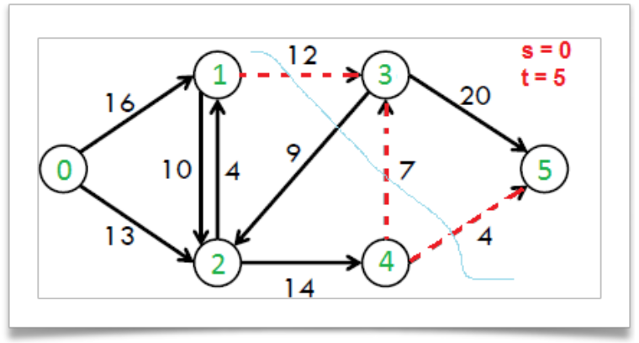

T**he traveling salesman:** Which describes a salesman who must travel between **N** cities to sell his products and ultimately finish at his starting point. Each city is connected by nodes with different weights indicating the different possibilities of vehicles and or distance between the cities which ultimately become the cost of the travel, the salesman objective is to spend the least amount of money in-between his travels so that the profit becomes higher (Mazurek, 2019).

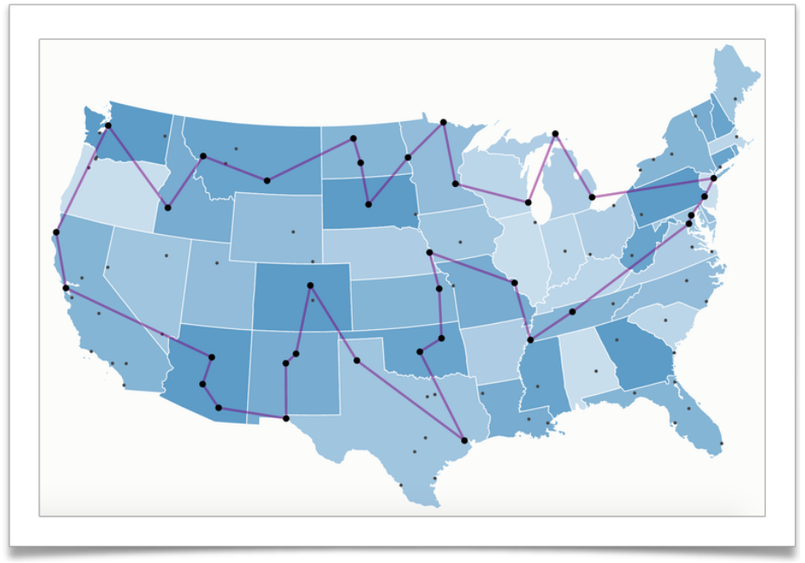

(Mazurek, 2019)

The least obvious applications are:

**Max bottleneck paths:** It is described as the widest path between a source*A*andits target *B*, all of the flow that goes across the widest path will be the same as the amount of the minimum weight on the path.

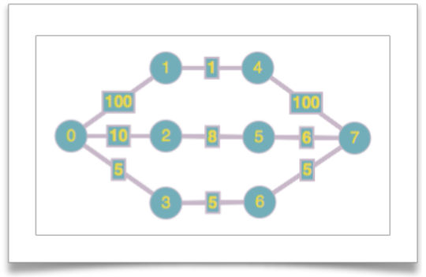

**Low-density parity-check code (LDPC):** Which is a correction code that functionslinearly, sending a message over a transmission channel.

**Image registration / Renyi entropy:** This is an important task of image processing,it has been developed in many different ways, one of them performed by minimizing the length of the minimum spanning tree.

Amongst others, such as “reducing data storage in sequencing amino acids in a protein, model locality of particle interactions in turbulent fluid flows and the auto-configuration protocol for ethernet bridging to avoid cycles in a network” (geeksforgeeks, 2018).

Its other practical applications are; 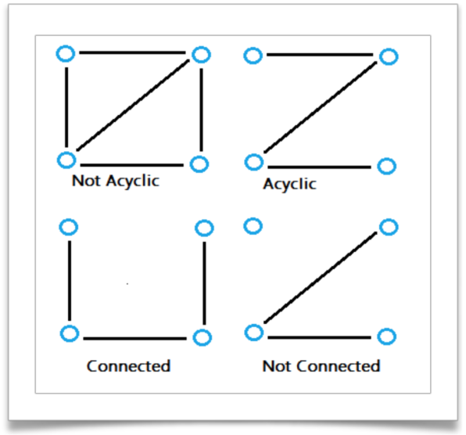**Cluster**

**Analysis, Handwriting recognition** and

**Image segmentation** (Stephanie, 2017).

A regular tree has only one path which joins any two vertices, but a **spanning tree** of a graph is a tree that contains all of the original vertices, it reaches out to all of them and it does not have any loops which come back to themselves.

Just one graph can contain multiple possibilities of spanning trees, the ones shown on our right are not even all of the possible outcomes(Stephanie, 2017).

**Minimum Spanning Tree**

**What is Spanning Tree?**

Given an erratic and connected **Graph** **G = (V, E)**, a spanning tree of the **graph G** is a tree that spans **V** (That is, it includes every vertex of **G**) and is a **Sub-Graph** of **E**( every edge in the tree belongs to **G**)[1] or it can be described as a subset of **Graph** **G,** where it has to cover ***all vertices with least number of edges***. Therefore it doesn’t have cycles and it is connected very well.

A conclusion can be drawn, which tells us that every connected and un-directed **Graph G** has at least one spanning tree **(** For spanning tree, the condition of a connected graphshould be fulfilled**)**. With a simple graph in figure1, we can show how to get a possible spanning tree from a connected graph.

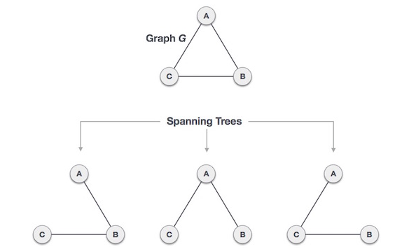

(Figure 1, Example showing the Possible Spanning Tree from a Connected Graph[2])

Here we can have ***3 Spanning Trees****,* we can derive the number of possible Spanning Tree by using the Formula, **nn-2** as the number of maximum Spanning Trees, where **n is the number of nodes**, in above figure **n is 3**, hence **33-2 = 3**, so the possible Spanning Trees in the above figure is 3, which is shown in the same figure.

**Application of Spanning Tree**

The Applications where Spanning Tree is used are:

* **Civil Network Planning**
* **Computer Network Routing Protocol**
* **Cluster Analysis**

**Now How the Minimum spanning Tree is different from the Spanning Tree?**

First and foremost, we have to understand that the weight between two nodes is involved, therefore the Spanning Tree with the least weight is considered to be the **Minimum Spanning Tree**. The weight can be characterized as follows, in real-world situations, it can be a **distance, congestion, traffic load, or anything that could possesses some weight or value in it and it can have arbitrary nature**. In figure 2, the difference between a Spanning Tree and Minimum Spanning Tree is shown, as it is clearly decided by the weight.

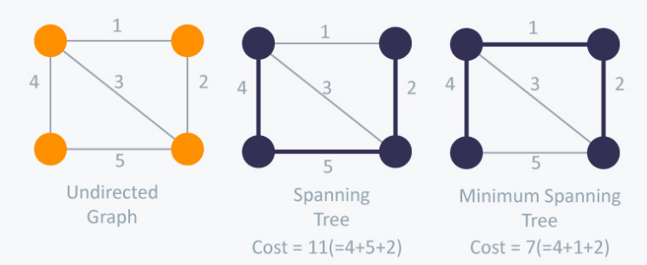(Figure 2, Difference Spanning Tree and Spanning Tree[3], HackerEarth )

**Minimum Spanning-Tree Algorithm**

The two most important algorithm, which can be used to define the Minimum spanning Tree are:

**(1) Kruskal’s Algorithm**

**(2) prim’s Algorithm**

**Kruskal’s Algorithm**

It is a growing spanning tree, which adds the edges one by one and so on it grows. It uses the weight while adding each edge using iteration. If we have to build a Minimum Spanning Tree then first we have to segregate the edges according to their weights. Then we have to start adding edges to tree one by one with the smallest weight in the beginning and then the largest weight in the end. Also while doing this we have to keep in the mind that we shouldn’t add the edges which will form a cycle or a loop in other words only connect those which are disconnected.

There is a very important term in this algorithm is, **“Connecting the edges which are disconnected”**. What does it means that We have to check every single time that previous vertex and the current vertex is visited earlier or not? If yes then they shouldn’t be connected and we should move to the next least weight. So the best solution for this algorithm is known as **“Disjoint Sets”**.

The Time complexity can be described as **O(V+E)** where **V** is the number of vertices, **E** is the number of edges.

We can understand it more by using the example given in Figure3, where we are going to calculate the **Minimum Spanning Tree** using the KRUSKAL’S algorithm.

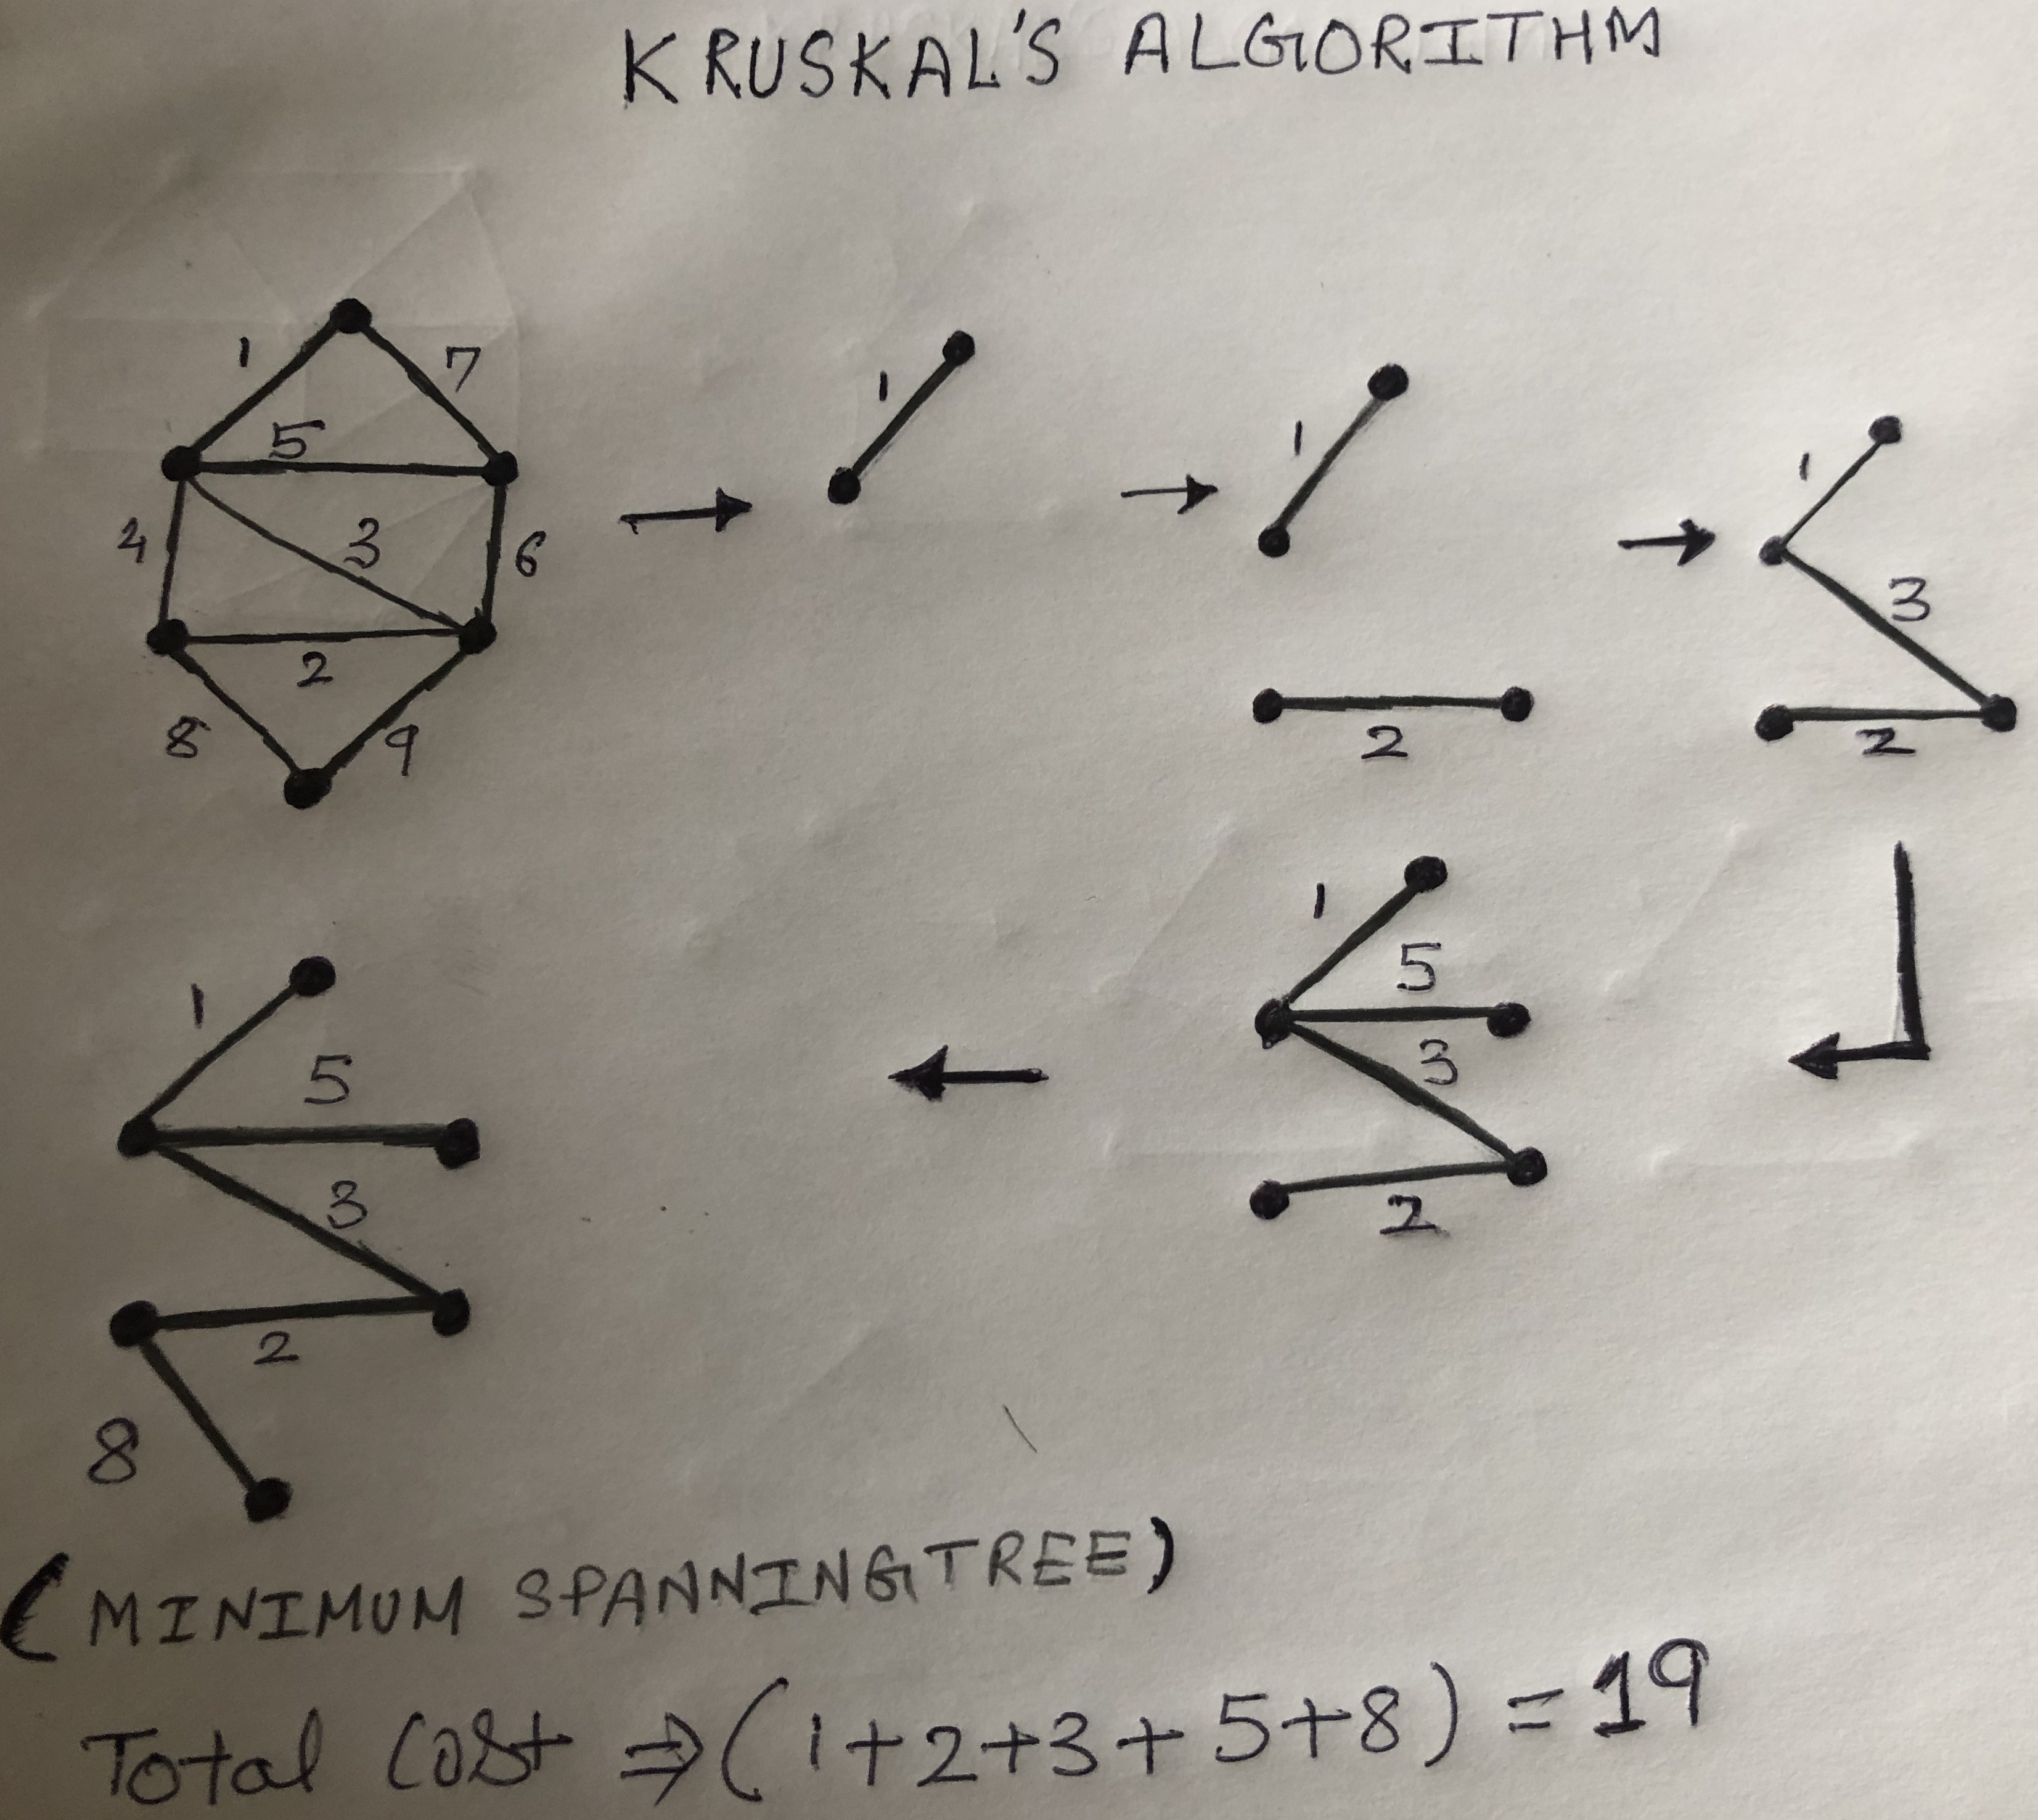(Figure 3, Minimum Spanning Tree using KRUSKAL’s algorithm[3], Rawat Nitin Singh)

In the above figure, we had a spanning tree which we converted into a Minimum Spanning Tree by using the KRUSAL’S algorithm. We started with the least weight and then we grew the vertices by following the greedy approach in which we selected the next least weight, here we started with weight 1. After that, we selected weight 2 which is the next lowest weight. Here we have to notice that these two edges are disjoint. Now the next one is 3 which is least then 4 and also we have to prevent ourselves to create a cycle. Thus we go on with 5 and the same as before we will not select 6 and 7 as they will create a cycle. Now we select 8 in comparison 9 as it is least. Now we have the **Minimum Spanning Tree,** connecting all the vertices at the cost of 19.

**Implementation**

Here is the implementation of KRUSKAL’s algorithm done in Python programming language[4]

# Python program for Kruskal's algorithm to find

# Minimum Spanning Tree of a given connected,

# undirected and weighted graph

from collections import defaultdict

#Class to represent a graph

class Graph:

def __init__(self,vertices):

self.V= vertices #No. of vertices

self.graph = [] # default dictionary

# to store graph

# function to add an edge to graph

def addEdge(self,u,v,w):

self.graph.append([u,v,w])

# A utility function to find set of an element i

# (uses path compression technique)

def find(self, parent, i):

if parent[i] == i:

return i

return self.find(parent, parent[i])

# A function that does union of two sets of x and y

# (uses union by rank)

def union(self, parent, rank, x, y):

xroot = self.find(parent, x)

yroot = self.find(parent, y)

# Attach smaller rank tree under root of

# high rank tree (Union by Rank)

if rank[xroot] < rank[yroot]:

parent[xroot] = yroot

elif rank[xroot] > rank[yroot]:

parent[yroot] = xroot

# If ranks are same, then make one as root

# and increment its rank by one

else :

parent[yroot] = xroot

rank[xroot] += 1

# The main function to construct MST using Kruskal's

# algorithm

def KruskalMST(self):

result =[] #This will store the resultant MST

i = 0 # An index variable, used for sorted edges

e = 0 # An index variable, used for result[]

# Step 1: Sort all the edges in non-decreasing

# order of their

# weight. If we are not allowed to change the

# given graph, we can create a copy of graph

self.graph = sorted(self.graph,key=lambda item: item[2])

parent = [] ; rank = []

# Create V subsets with single elements

for node in range(self.V):

parent.append(node)

rank.append(0)

# Number of edges to be taken is equal to V-1

while e < self.V -1 :

# Step 2: Pick the smallest edge and increment

# the index for next iteration

u,v,w = self.graph[i]

i = i + 1

x = self.find(parent, u)

y = self.find(parent ,v)

# If including this edge does't cause cycle,

# include it in result and increment the index

# of result for next edge

if x != y:

e = e + 1

result.append([u,v,w])

self.union(parent, rank, x, y)

# Else discard the edge

# print the contents of result[] to display the built MST

print("Following are the edges in the constructed MST")

for u,v,weight in result:

#print str(u) + " -- " + str(v) + " == " + str(weight)

print ("%d -- %d == %d" % (u,v,weight))

# Driver code

g = Graph(4)

g.addEdge(0, 1, 10)

g.addEdge(0, 2, 6)

g.addEdge(0, 3, 5)

g.addEdge(1, 3, 15)

g.addEdge(2, 3, 4)

g.KruskalMST()

**OUTPUT:**

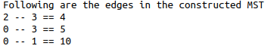

**Code Explanation:**

The class is created to find the **Minimum spanning Tree** for **KRUSKAL’S algorithm**, and it is named as ***KruskalMST()***, here what it will do that it will initialize an empty set named v, then it will run a **while Loop** till the number of edges is equal to V-1, at first it will pick the smallest edge and then by approaching the iterative approach moves to next index having least weight at that time and also checks for the cycle and if **u** and **v** are same then it will discard it and move to next edge by using **u** and **v**. If it is ok then it merges it by using the **union function** it will use the rank method and attach the smaller rank tree under the root of a higher rank tree if ranks are same them it will make one as rot and increment its rank by one and then the result will be appended in **result[]**.

**Time Complexity:**

Most of the time is taken by sorting in this algorithm because of the complexity of **Disjoint-Set operation**. Whereas it is given by, **Time Complexity = O(ELogE + ElogV)**, but the value of E can be at most **O(V2)**, so **O(LogV)** and **O(LogE)** are same. Therefore, the overall time complexity is **O(ELogV)**.

**PRIM’S ALGORITHM**

It also has the same approach of adding the vertices one by one but the only difference is that it uses starting position to grow upon, it means it starts with the starting point and then uses the other vertex connected to the same edge then afterward it uses the least weight of the vertex connected to the edge.

In Figure 4, we can understand how PRIM’s algorithm work. As we have said earlier, we are going to start with the Starting Point which is 1 (which is also the least weight) over here, so we draw both edges. Then we draw the whole connected vertices with the starting point. Which are 2, 3, and 7! Then we increase the vertices using the iteration approach by looking for the least weight vertices. As it is 5 and it is the only one which is not making a loop or a cycle with the other edges. Thus, it will be added and by adding it we have all the edges covered in our Minimum Spanning Tree.

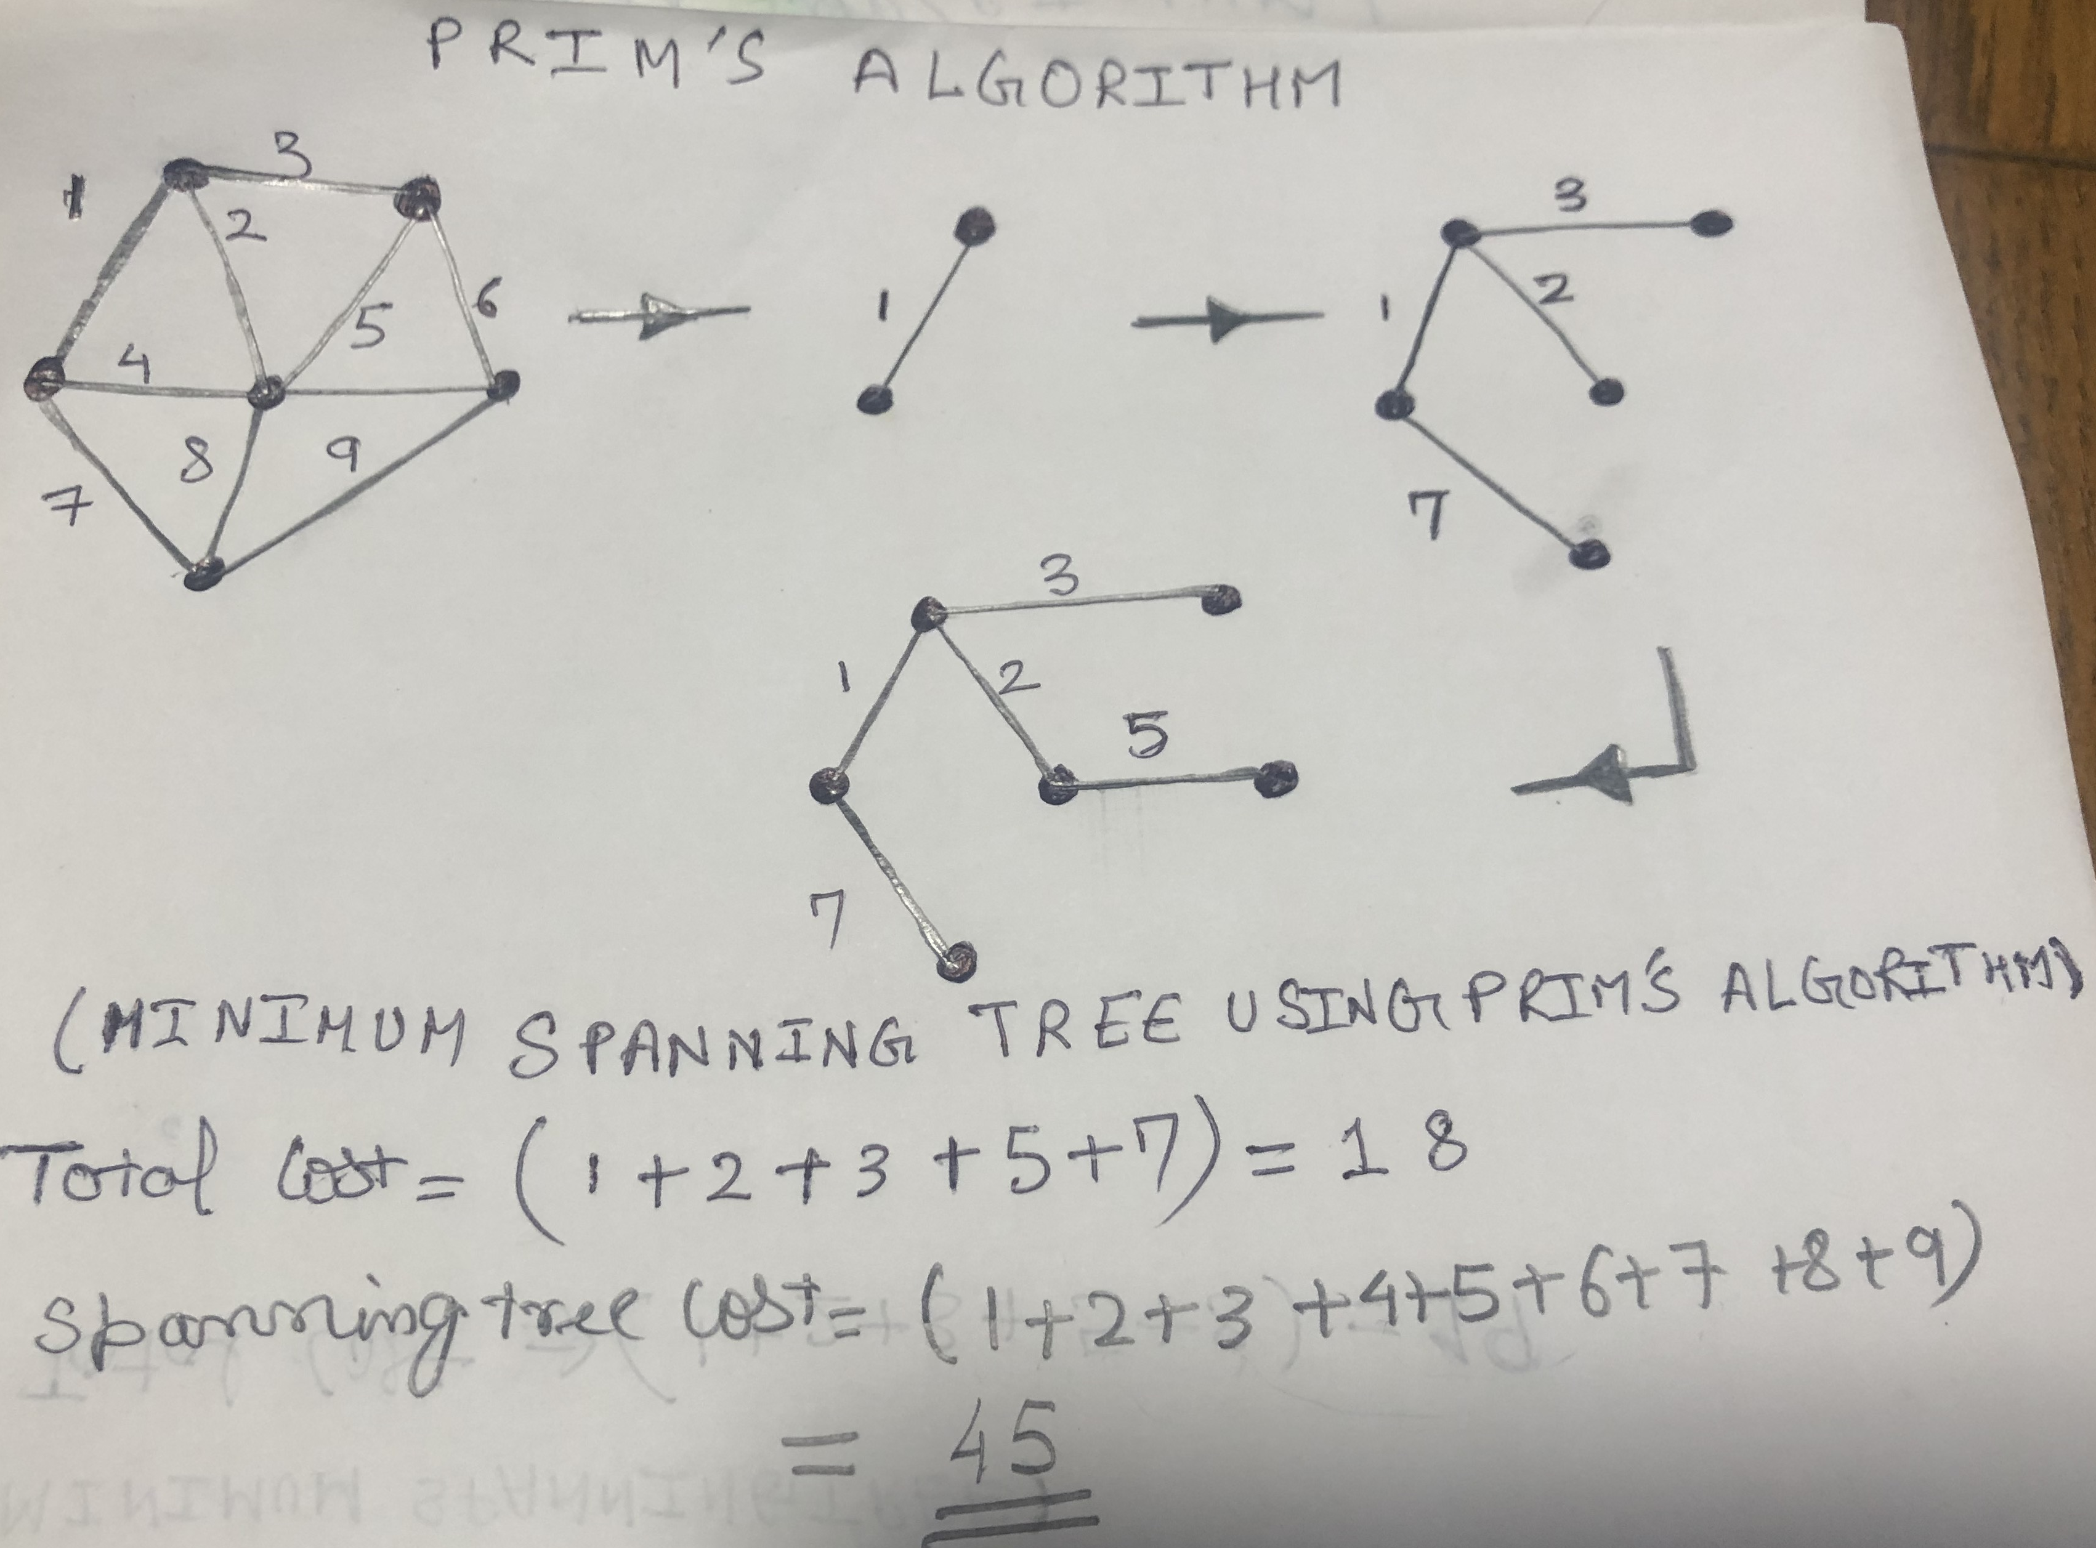

(Figure 5, Minimum Spanning Tree using PRIM’s algorithm[4], Rawat Nitin Singh)

These are the rules which we have to follow while making the Minimum Spanning Tree with PRIM’s algorithm is described as follows:

1. Two disjointed sets of vertices are used, in one vertex is growing into a spanning tree and the other one is not growing in the spanning tree.
2. We select the lightest weight vertex connecting the spanning tree and while doing this we shouldn’t select the vertices which are already in the spanning tree. This is usually done by using the Priority Queues, as we use the priority while adding the vertices to our iterative spanning Tree.
3. Also as it was the same in the KRUSKAL’s Algorithm cyclic nature was avoided, so does in this case also. Which are segregated while considering the Priority for the vertices!

**Implementation**

Here is the implementation of PRIM’s algorithm done in the Python programming language[6].

# A Python program for Prim's Minimum Spanning Tree (MST) algorithm.

# The program is for adjacency matrix representation of the graph

import sys # Library for INT_MAX

class Graph():

def __init__(self, vertices):

self.V = vertices

self.graph = [[0 for column in range(vertices)]

for row in range(vertices)]

# A utility function to print the constructed MST stored in parent[]

def printMST(self, parent):

print("Edge \tWeight")

for i in range(1, self.V):

print(parent[i], "-", i, "\t", self.graph[i][ parent[i] ])

# A utility function to find the vertex with

# minimum distance value, from the set of vertices

# not yet included in shortest path tree

def minKey(self, key, mstSet):

# Initilaize min value

min = sys.maxsize

for v in range(self.V):

if key[v] < min and mstSet[v] == False:

min = key[v]

min_index = v

return min_index

# Function to construct and print MST for a graph

# represented using adjacency matrix representation

def primMST(self):

# Key values used to pick minimum weight edge in cut

key = [sys.maxsize] * self.V

parent = [None] * self.V # Array to store constructed MST

# Make key 0 so that this vertex is picked as first vertex

key[0] = 0

mstSet = [False] * self.V

parent[0] = -1 # First node is always the root of

for cout in range(self.V):

# Pick the minimum distance vertex from

# the set of vertices not yet processed.

# u is always equal to src in first iteration

u = self.minKey(key, mstSet)

# Put the minimum distance vertex in

# the shortest path tree

mstSet[u] = True

# Update dist value of the adjacent vertices

# of the picked vertex only if the current

# distance is greater than new distance and

# the vertex in not in the shotest path tree

for v in range(self.V):

# graph[u][v] is non zero only for adjacent vertices of m

# mstSet[v] is false for vertices not yet included in MST

# Update the key only if graph[u][v] is smaller than key[v]

if self.graph[u][v] > 0 and mstSet[v] == False and key[v] > self.graph[u][v]:

key[v] = self.graph[u][v]

parent[v] = u

self.printMST(parent)

g = Graph(5)

g.graph = [ [0, 2, 0, 6, 0],

[2, 0, 3, 8, 5],

[0, 3, 0, 0, 7],

[6, 8, 0, 0, 9],

[0, 5, 7, 9, 0]]

g.primMST();

**OUTPUT:**

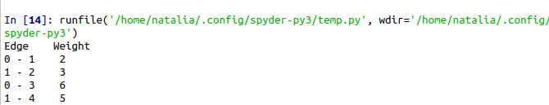

**CODE EXPLANATION:**

Here an array mstSet[] is used to imitate the set of vertices comprised in MST. “If the a value mstset[v] is true, then vertex v is included in MST, otherwise not”[7]. Key stored in an array named key[] and another array is used to store the indexes. The Output is constructed using the Minimum Spanning Tree using the PRIM’s Algorithm of using the starting as the growing point.

**Time Complexity:**

In this case, Time complexity is given by ***O((V+E)logV)***because each vertex is added iteratively upon its **Priority queue** in a logarithmic manner.

**APPLICATION:**

If we overall think about the application of the Minimum Spanning Tree, then it can be easily stated as, “Creating an efficient and least costly Network”. As it is related to delivering the data, message, information, goods, or service to the various place by the single point of sources. We can understand it by taking the Postal Delivery system as an example, where all the posts are distributed from the Head Post Office to the Branch Post Office and then to the corresponding addresses. As to do it cost-effectively and Time-saving manner they have developed their route every single day as the endpoints change every day with the new posts generated every day.

In the context of Information Technology, it is given as follows,

* Network Designing for Internet Domain Company, Telephonic Companies.
* For designing broadcasting networks for computer networks on a LAN.
* Image Processing related to registration and segmentation.
* Handwriting recognition of mathematical expressions.

The other non-IT based applications are as follows;

* Postal System.
* Goods delivery system particularly in Logistics.
* Topological surveys in power systems designing for the Cities.
* Measuring homogeneity of two-dimensional materials.

Here is one of the examples in Figure 6,7,8 displaying how the Minimum Spanning Tree approach is being used in practice.

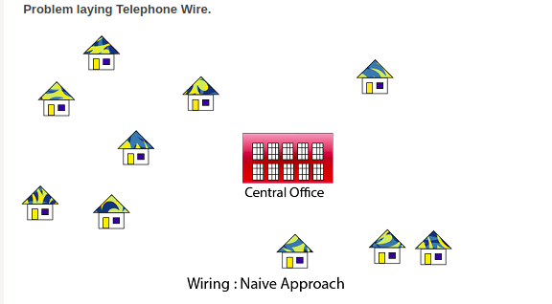

(Figure 6, Spanning Tree Application [8], Javapoint.com)

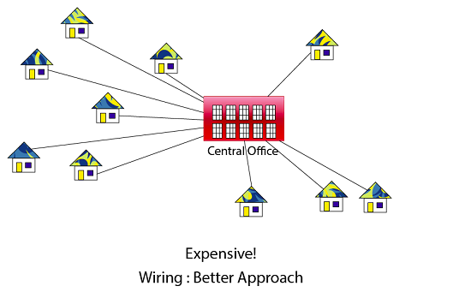

(Figure 7, Spanning Tree Application [8], Javapoint.com)

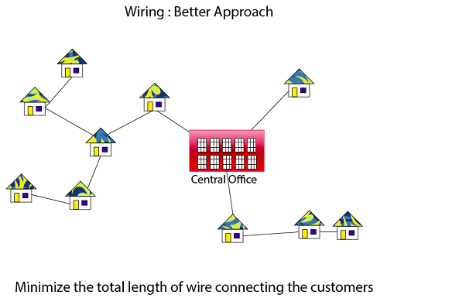

(Figure 8, Spanning Tree Application [8], Javapoint.com)

**Reference**

**[1][3] Minimum Spanning Tree,** [**https://hackerearth.com/ja/practice/algorithms/graphs/minimum-spanning-tree/tutorial**](https://hackerearth.com/ja/practice/algorithms/graphs/minimum-spanning-tree/tutorial)

**hackerEarth, 2020.**

**[2] Spanning Tree,** [**https://www.tutorialspoint.com/data_structures_algorithms/spanning_tree.html**](https://www.tutorialspoint.com/data_structures_algorithms/spanning_tree.html)

**[3] Spanning Tree using KRUSKAL’S algorithm, Rawat Nitin Singh, KCGI, July 2020.**

**[4] Implementation of KRUSKAL'S algorithm in Python, NEELAM YADAV,** [**https://www.geeksforgeeks.org**](https://www.geeksforgeeks.org/)**, Uttar Pradesh, India**

**[5] Spanning Tree using PRIM's algorithm, Rawat Nitin Singh, KCGI August 2020.**

**[****6][7] Implementation of PRIM'S algorithm in Python, DIVYANSHU MEHTA,** [**https://www.geeksforgeeks.org**](https://www.geeksforgeeks.org/)**, Uttar Pradesh, India**

**[8] Minimum Spanning Tree Application in Telephonic System, 2018,** [**https://www.**](https://www.geeksforgeeks.org/)**Javapoint.com, Noida, Uttar Pradesh, India**

**[9]Stephanie. (2017, October 24). Minimum Spanning Tree: Definition, Examples, Prim's Algorithm. Retrieved July 21, 2020, from https://www.statisticshowto.com/minimum-spanning-tree/**

**[10]W. (2017, December 11). Minimum spanning tree. Retrieved July 21, 2020, from** [**https://sim**](https://simple.wikipedia.org/wiki/Minimum_spanning_tree)**-**[**ple.wikipedia.org/wiki/Minimum_spanning_tree**](https://simple.wikipedia.org/wiki/Minimum_spanning_tree)

**[11]W. (2019, October 21). Traveling salesman problem. Retrieved July 21, 2020, from** [**https://**](https://simple.wikipedia.org/wiki/Travelling_salesman_problem)[**simple.wikipedia.org/wiki/Travelling_salesman_problem**](https://simple.wikipedia.org/wiki/Travelling_salesman_problem)

**[12]Kumar, V. (n.d.). Min-cut Tutorials & Notes: Algorithms. Retrieved July 21, 2020, from** [**https://www.hackerearth.com/ja/practice/algorithms/graphs/min-cut/tutorial/**](https://www.hackerearth.com/ja/practice/algorithms/graphs/min-cut/tutorial/)

**[13]Mazurek, F. (2019, October 17). Quantum Traveling Salesman. Retrieved July 30, 2020, from** [**http://filipworks.tech/projects/tsp-qiskit/**](http://filipworks.tech/projects/tsp-qiskit/)

**[14]P. (2019, September 18). Find minimum s-t cut in a flow network. Retrieved July 30, 2020, from** [**https://www.geeksforgeeks.org/minimum-cut-in-a-directed-graph/**](https://www.geeksforgeeks.org/minimum-cut-in-a-directed-graph/)

**[15]Applications of Minimum Spanning Tree Problem. (2018, February 12). Retrieved August 03, 2020, from https://www.geeksforgeeks.org/applications-of-minimum-spanning-tree/**

**[16]Neal, B. (2015, November 22). What is the maximum-bottleneck (s,t)-path in the context of maximum flow? Retrieved August 03, 2020, from https://www.quora.com/What-is-**[**the-maximum-bottleneck-s-t-path-in-the-context-of-maximum-flow**](https://www.quora.com/What-is-the-maximum-bottleneck-s-t-path-in-the-context-of-maximum-flow)

**[17]Ma, B., Hero, A., Gorman, J., & Michel, O. (n.d.). Image registration with minimum spanning tree algorithm. *Proceedings 2000 International Conference on Image Processing* *(Cat. No.00CH37101)*. doi:10.1109/icip.2000.901000**

**[18]Geeksforgeeks. (2019, September 30). Kruskal's Minimum Spanning Tree Algorithm: Greedy Algo-2. Retrieved August 03, 2020, from https://www.geeksforgeeks.org/kruskals-minimum-spanning-tree-algorithm-greedy-algo-2/**